**GLOBAL SALES DATA ANALYTICS**

**PROJECT REPORT**

***Submitted by***

**UDAY KUMAR.V (TL) 111619104156**

**T.VATSAL (TM 1) 111619104154**

**SOMUNATH.S (TM 2) 111619104139**

**SAI KUMAR.R (TL 3) 111619104121**

**JEYANTH .V (TM 4) 111619104164**

**BACHELOR OF ENGINEERING**

**IN**

**COMPUTER SCIENCE AND ENGINEERING**

**TEAM ID**:**PNT2022TMID14480**

**TABLE OF CONTENTS**

|  |  |
| --- | --- |
| **S.NO** | **TITLE** |
| **1** | **INTRODUCTION** |
| 1.1 | Project Overview |
| 1.2 | Purpose |
| **2** | **LITERATURE SURVEY** |
| 2.1 | Existing problem |
| 2.2 | References |
| 2.3 | Problem Statement Definition |
| **3** | **IDEATION &PROPOSED SOLUTION** |
| 3.1 | Empathy Map Canvas |
| 3.2 | Ideation & Brainstorming |
| 3.3 | Proposed Solution |
| 3.4 | Problem Solution Fit |
| **4** | **REQUIREMENT ANALYSIS** |
| 4.1 | Functional requirements |
| 4.2 | Non-Functional requirements |
| **5** | **PROJECT DESIGN** |
| 5.1 | Data Flow Diagrams |
| 5.2 | Solution &Technical Architecture |
| 5.3 | User Stories |
| **6** | **PROJECT PLANNING & SCHEDULING** |
| 6.1 | Sprint Planning & Estimation |
| 6.2 | Sprint Delivery Schedule |
| 6.3 | Reports from JIRA |
| **7** | **CODING & SOLUTIONING** |
| 7.1 | Feature 1 |
| 7.2 | Feature 2 |
| 7.3 | Database Schema |
| **8** | **TESTING** |
| 8.1 | Test Cases |
| 8.2 | User Acceptance Testing |
| **9** | **RESULTS** |
| 9.1 | Performance Metrics |
| **10** | **ADVANTAGES & DISADVANTAGES** |
| **11** | **CONCLUSION** |
| **12** | **FUTURE SCOPE** |
| **13** | **APPENDIX** |

**1.INTRODUCTION**

* 1. **PROCJECT OVERVIEW:**
* KnowfundamentalconceptsandcanworkonIBMCognosAnalytics.
* Gainabroadunderstandingofplottingdifferentvisualizationstoprovideasuitablesolution.
* AbletocreatemeaningfulVisualizationsandDashboard(s).
  1. **PURPOSE**

Sales Analysis is the process of understanding how your business performs in terms of sales. It provides insights into the past, present, and future performance of a business and can be used to help you forecast trends, identify opportunities for growth, and develop a strategic action plan for your company

**2.LITERATURE SURVEY**

**2.1 EXISTING SYSTEM**

Sales analytics products access data solely from sales tools, and their core functionality is to analyze sales information. Some companies opt to use [business intelligence platforms](https://www.g2.com/categories/business-intelligence-platforms) and [self-service business intelligence software](https://www.g2.com/categories/self-service-business-intelligence) instead, which can also provide companies insights into their data from a variety of other sources in addition to sales data.

Sales analytic insights can be used to improve sales strategies and implement a more predictable sales model.

**2.2 REFERENCES**

1.McKnight, D. H., Choudhury, V. and Kacmar, C., “Developing and validating trust measures for e-commerce: an integrative typology,” Information Systems Research.

2.Michal, P., ‘On-line Shopping on B2C Markets in the Czech Republic,” Journal of Competitiveness.

3.Mckinsey& Company, Online and Upcoming: The Internet’s Impact on India, 2012, Retrieved on Nov 10, 2014 from http://www.mck insey.com/~/media/mckinsey%20 offices/india/pdfs/online and _upcoming_the_internets_impact_on_india.ashx.

4.Nielson Global Report, “Ecommerce: evolution or revolution in the fast-moving consumer goods world,” 2014, Retrieved on Oct 15, 2014 from <http://ir.nielsen.com/files/doc_financials/Nielsen-Global-Ecommerce-Report-August-2014.pdf>.

**2.3 PROBLEM STATEMENT DEFINITIONS**

If you clearly define your problem statement and intend to collect the data needed to solve the problem yourself, you could design your data collection methods to perfectly align to your question.when you’re working with found data, you are limited by the biases, caveats, and data collection methods that the creators employed when the data were collected. That means that if you are defining your problem statement based on an existing dataset, you need to take all of these factors into account.

**3.IDEATION&PROPOSED SOLUTION**

**3.1EMPATHY MAP CANVAS**

An empathy map helps you identify with a customer’s thoughts, feelings, and behaviors. Product teams often use empathy mapping to improve the user experience. In this article, learn how to build an empathy map and use it to improve your business strategy.

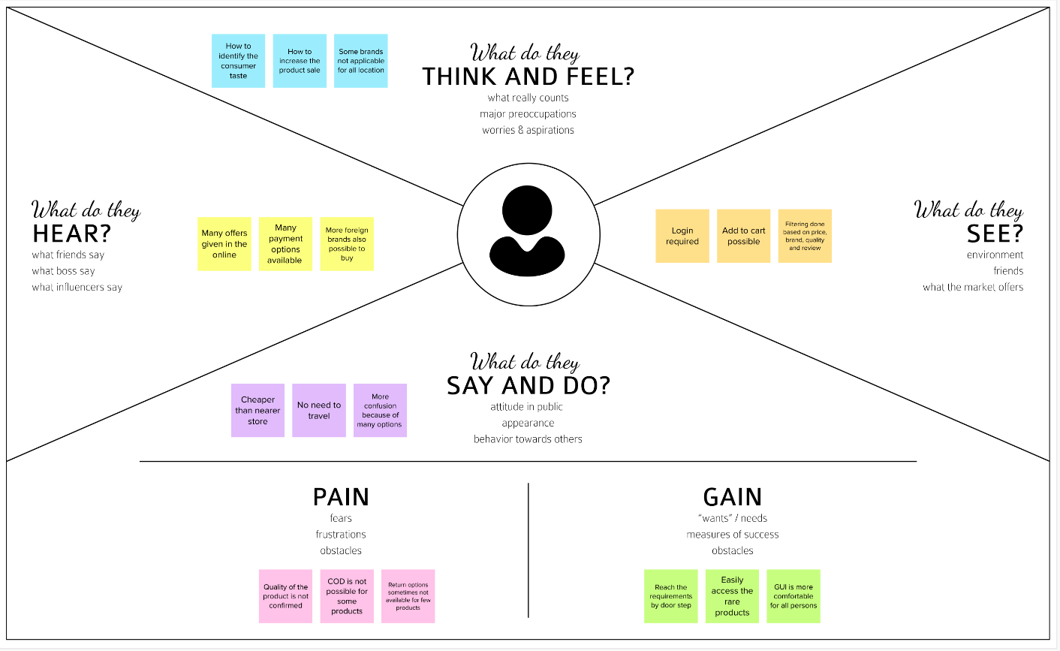

**3.2 IDEATION & BRAINSTROMING**

STEP-1:TEAMGATHERING,COLLEBRATIONANDSELECTTHEPROBLEMSTATMENT

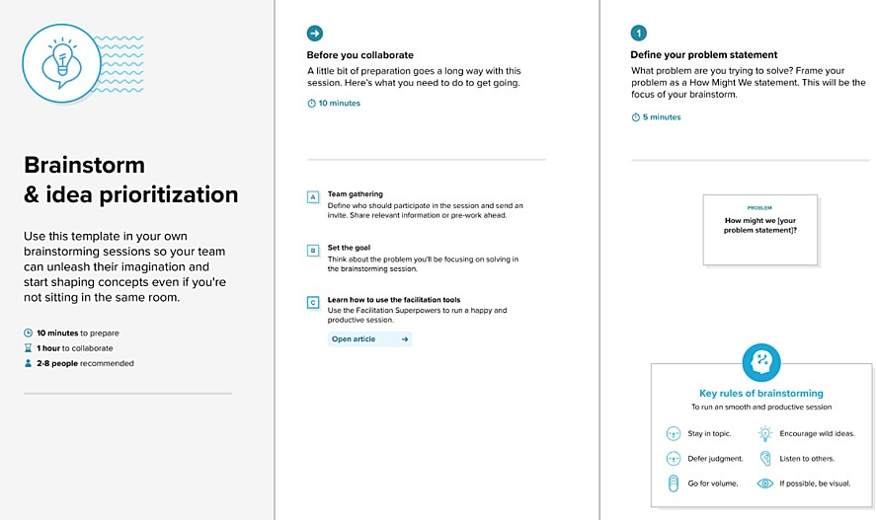

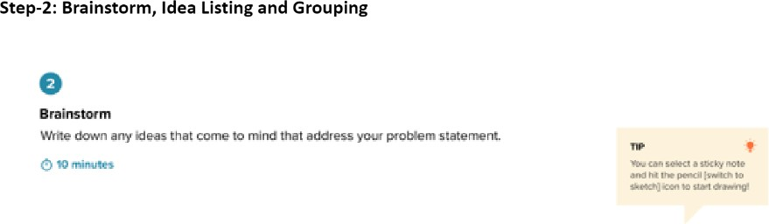

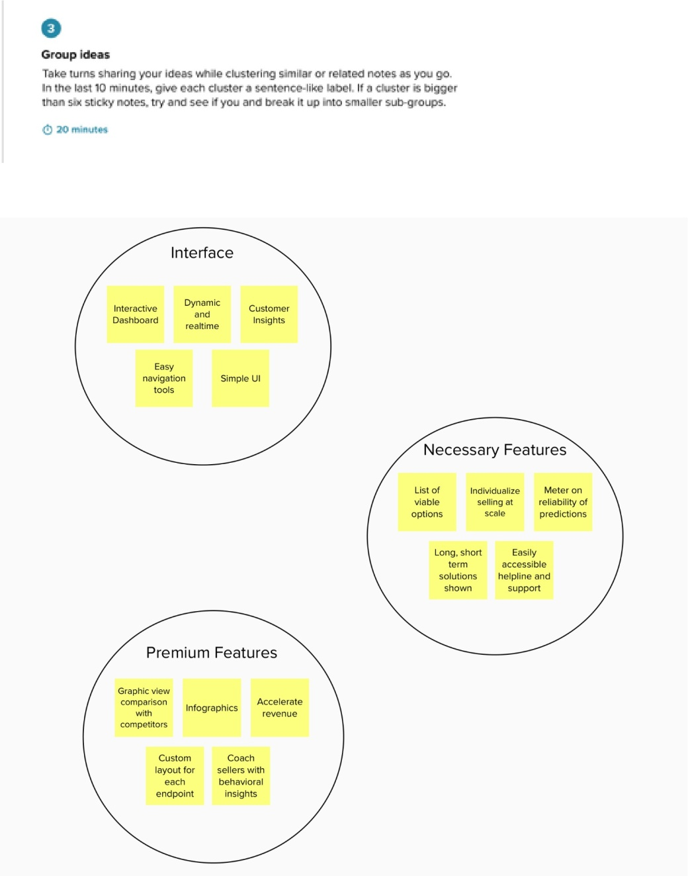

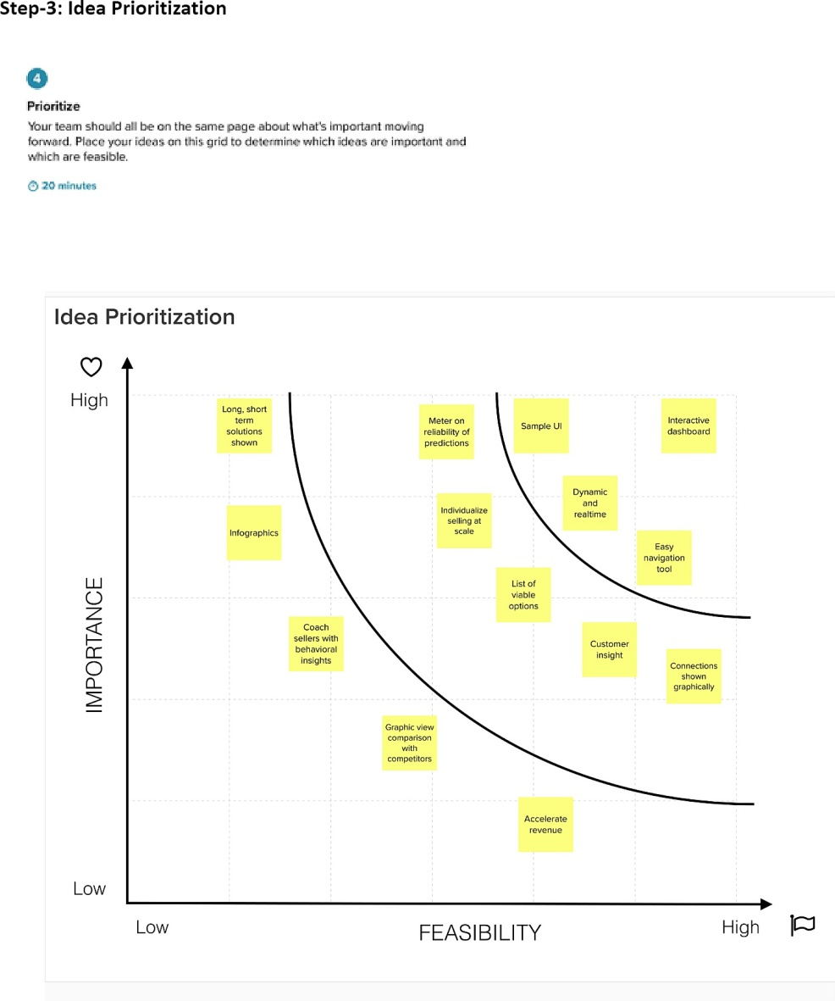

**3.3 PROPOSED SOLUTION**

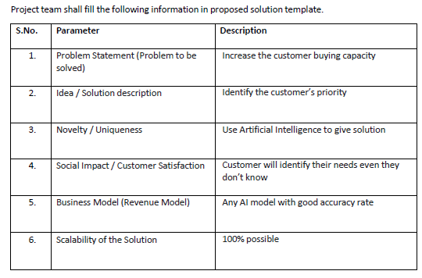

**3.4 PROBLEM SOLUTIONS FIT**

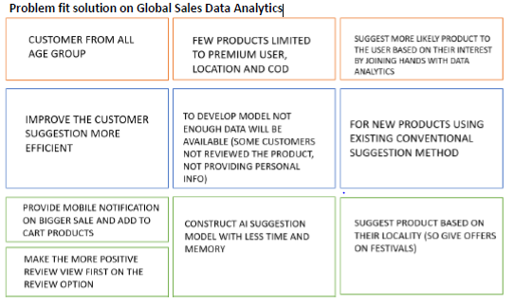

4.REQUIREMENT ANALYSIS

4.1 FUNCTION REQUIREMENT

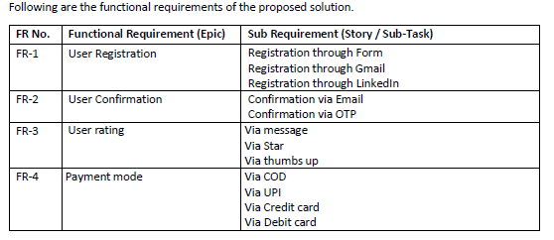

**5.PROJECT DESIGN**

**5.1 DATA FLOW DIAGRAMS**

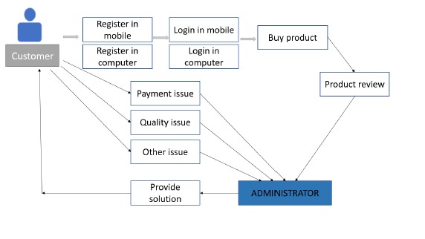

**5.2 SOLUTION & TECHNICAL ARCHITECTUES**

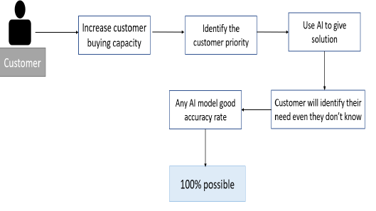

**5.3 USER STORIES**

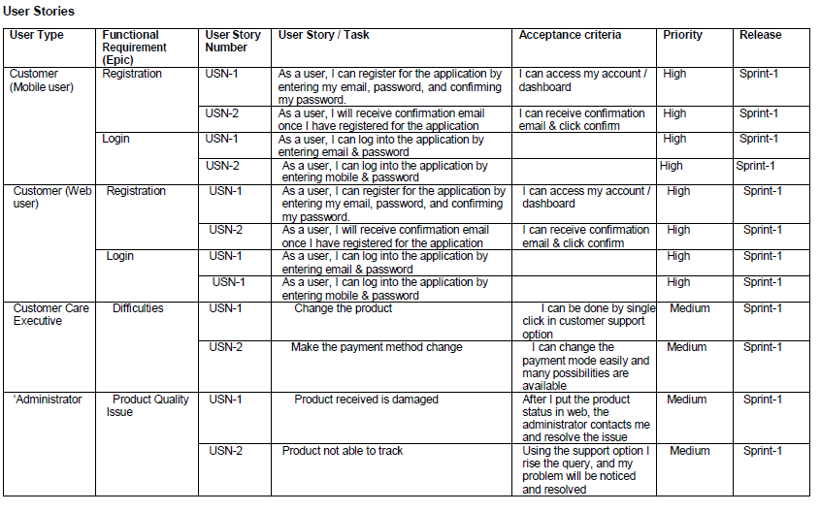

**6.PROJECT PLANNING & SCHEDULING**

**6.1 SPRINT PLANNING & ESTIMATION**

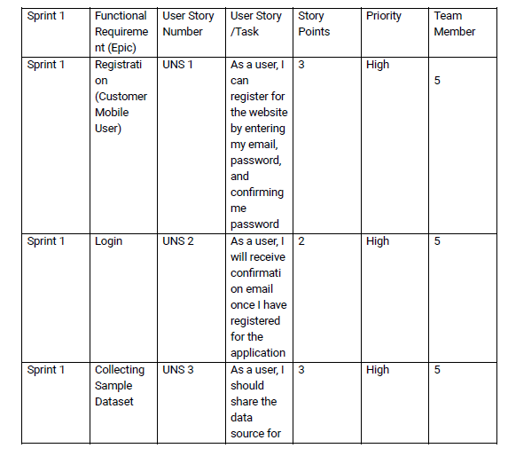

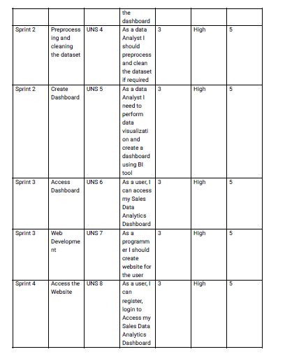

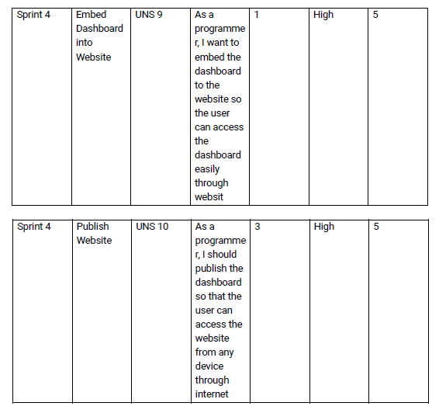

**6.2 SPRINT DELIVERY SCHEDULE**

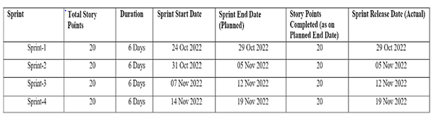

**Velocity:**

We have a 24-day sprint duration, and the velocity of the team is 20 (points per sprint). Let’s calculate the team’s average velocity (AV) per iteration unit (story

points per day)

**AV = Sprint Duration / Velocity = 20 / 10 = 2**

**Burndown Chart :**

A burn down chart is a graphical representation of work left to do versus time. It is often used in agile software development methodologies such as Scrum. However, burn down charts can be applied to any project containing measurable progress over time.

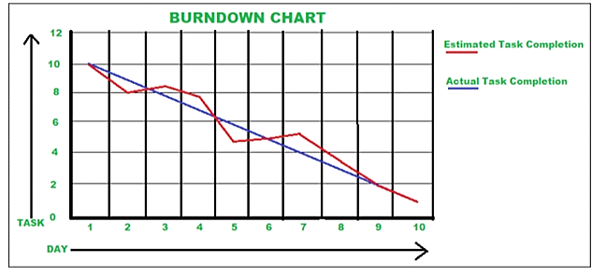

**6.3 Reports from JIRA :**

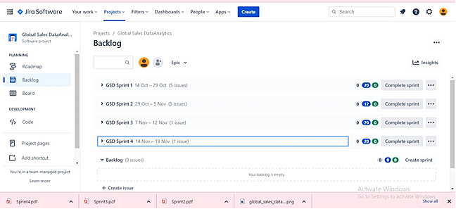

**Burndown chart :**

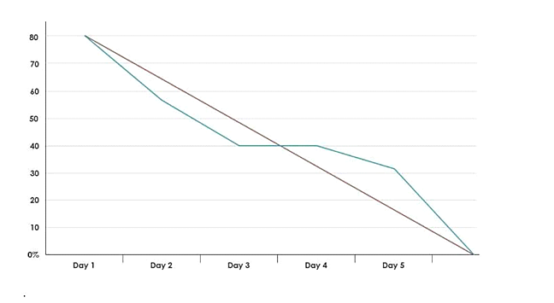

**Road Map:**

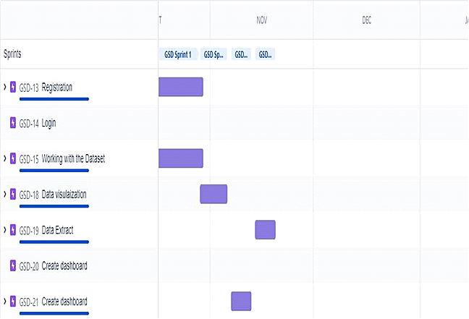

**7. CODING SOLUTIONING**

**7.1.1Feature 1**

**Sales – Analysis:**

This is an analysis of the sales data with particular focus given to how promotions and advertising translate into sales, in terms of both units sold and sales dollars.

**Different types of Sales Analysis**

* Furniture company sales analysis HTML file
* Cereal Company Sales Analysis HTML file
* Financial Statement Analysis PDF file

**Analysis using R Shiny Dashboard**

* Furniture company sales Dashboard R Shiny app

**Steps for Cereal Company Sales Analysis**

1**.** Download the Raw Data

2. Analysis code R file

3. Final Analysis R file

**Steps for Furniture company sales analysis**

1. Download the Raw Data

2. Analysis code R file

3. Dashboard Code HTML file

4. Final Dashboard PDF file

5. Final Analysis HTML file

**fearture-1:**

**Step 1: Understand the Business**

**Step 2: Get Your Data**

**Step 3: Explore and Clean Your Data**

**Step 4: Enrich Your Datasets**

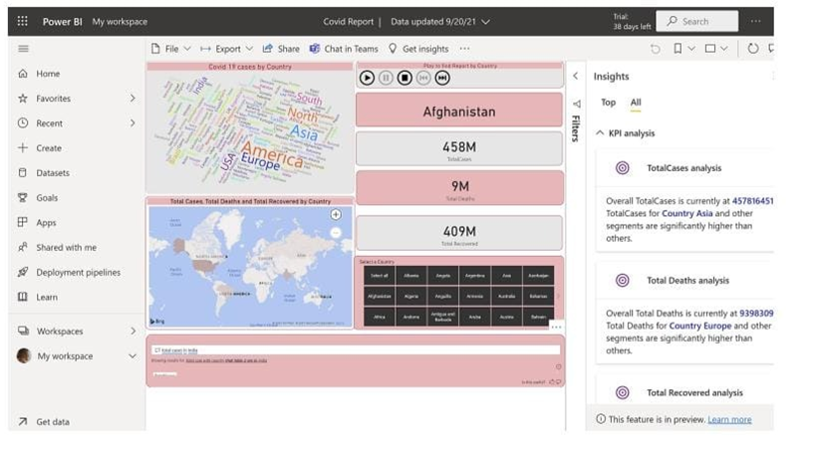

**8.TESTING**

**8.1 USER ACCEPTANCE TESTING**

# PurposeofDocument

The purpose of this document is to briefly explain thetestcoverageandopenissuesofthe [Global sales data analytics] project at the time of the release to User Acceptance Testing (UAT).

# DefectAnalysis

Thisreportshowsthenumberofresolvedor closed bugs at each severity level, and how they were resolved

|  |  |  |  |  |  |
| --- | --- | --- | --- | --- | --- |
| **Resolution** | **Severity1** | **Severity2** | **Severity3** | **Severity4** | **Subtotal** |
| By Design | 9 | 3 | 2 | 3 | 18 |
| Duplicate | 1 | 0 | 3 | 0 | 4 |
| External | 2 | 3 | 0 | 1 | 6 |
| Fixed | 10 | 2 | 4 | 18 | 36 |
| Not Reproduced | 0 | 0 | 1 | 0 | 1 |
| Skipped | 0 | 0 | 1 | 1 | 2 |
| Won'tFix | 0 | 4 | 2 | 1 | 7 |
| Totals | 22 | 12 | 13 | 24 | 74 |

# TestCaseAnalysis

Thisreportshowsthenumberoftestcasesthathavepassed,failed,anduntested

|  |  |  |  |  |
| --- | --- | --- | --- | --- |
| **Section** | **TotalCases** | **Not Tested** | **Fail** | **Pass** |
| PrintEngine | 7 | 1 | 0 | 6 |
| ClientApplication | 49 | 2 | 1 | 46 |
| Security | 2 | 0 | 0 | 2 |
| OutsourceShipping | 2 | 0 | 0 | 2 |
| ExceptionReporting | 7 | 0 | 0 | 7 |
| FinalReportOutput | 6 | 0 | 0 | 6 |
| VersionControl | 2 | 0 | 0 | 2 |

**8.2 PERFORMANCE TESTING**

**Model Performance Testing:**

Project team shall fill the following information in model performance testing template.

|  |  |  |
| --- | --- | --- |
| **S.No.** | **Parameter** | **Screenshot / Values** |
|  | Dashboard design | No of Visulizations / Graphs - 7-8 visualization/6-7 graphs |
|  | Data Responsiveness | Users and Analyst or Developers |
| 3. | Amount Data to Rendered (DB2 Metrics) | 5 counrties |
| 4. | Utilization of Data Filters | Sales ,profit, products, market rate and order id filtration |
| 5. | Effective User Story | No of Scene Added - 30 user stories |
| 6. | Descriptive Reports | No of Visulizations / Graphs - 4 visualizations/6 graph |

**9.ADVANTAGES& DISADVANTAGES**

* **Advantages:**
* **Data analytics helps an organization make better decisions**
* **Increase the efficiency of the work**
* **The analytics keeps you updated of your customer behavioural changes**
* **Personalization of products and services**
* **Improving quality of products and services**
* **Disadvantages:**

security issues, ethical issues, the deliberate abuse of big data by malevolent players (e.g. organized crime), and unintentional misuse.

**10. CONCLUSION**

Data analysis includes the inspection, modification, modeling, and transforming of data as per the need of the research topic. The conclusion is the final inference drawn from the data analysis, review of literature, and findings.

**12.FUTURE SCOPE**

Sales analytics refers to the use of technology to collect and use sales data to derive actionable insights. It is used to identify, optimize, and forecast sales. It uses different metrics and KPIs to plan an efficient sales model that generates higher revenue for the business.

**APPENDEX**

**SOURCE CODE:**

<!DOCTYPE html>

<html>

<head>

<meta name="viewport" content="width=device-width, initial-scale=1">

<title> Login Page </title>

<style>

Body {

  font-family: Calibri, Helvetica, sans-serif;

  background-color:white;

  background-image: url('https://2h2fxj2oochv47z6ig3v0sve-wpengine.netdna-ssl.com/wp-content/uploads/2021/07/man-in-a-suit-standing-behind-a-hologram-of-data-analytics-1030x579.jpg');"

}

button {

       background-color:#c3e3dc;

       width: 100%;

        color: purple;

        padding: 15px;

        margin: 10px 0px;

        border: none;

        cursor: pointer;

         }

form {

        border: 3px solid #f156189;

    }

input[type=text], input[type=password] {

        width: 100%;

        margin: 8px 0;

        padding: 12px 20px;

        display: inline-block;

        border: 2px white;

        box-sizing: border-box;

    }

button:hover {

        opacity: 0.7;

    }

  .cancelbtn {

        width: auto;

        padding: 10px 18px;

        margin: 10px 5px;

    }

.container {

        padding: 25px;

<!--         background-color:pink; -->

    }

</style>

</head>

<body>

    <center> <h1>Login Form </h1> </center>

    <form>

        <div class="container">

            <label>Username : </label>

            <input type="text" placeholder="Enter Username" name="username" required>

            <label>Password : </label>

            <input type="password" placeholder="Enter Password" name="password" required>

            <button type="submit">Login</button>

            <input type="checkbox" checked="checked"> Remember me

            <button type="button" class="cancelbtn"> Cancel</button>

            <a href="#"> Forgot password? </a>

        </div>

    </form>

</body>

</html>

**Output:**

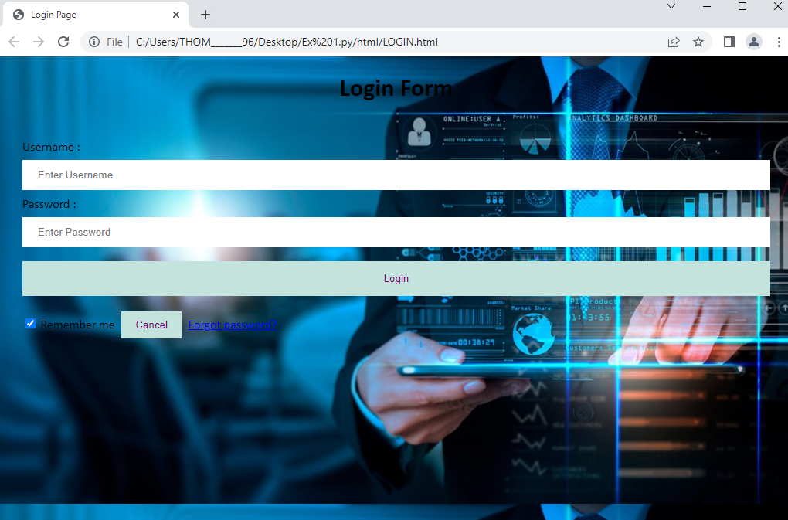

**GITHUB :** **<https://github.com/IBM-EPBL/IBM-Project-34256-1660233538>**

**PROJECT DEMO LINK:** [**https://drive.google.com/file/d/1opme9TYpOdSAZsFkwxRsXFiXIrH3p1SD/view?usp=share_link**](https://drive.google.com/file/d/1opme9TYpOdSAZsFkwxRsXFiXIrH3p1SD/view?usp=share_link)

THANK YOU !!!!